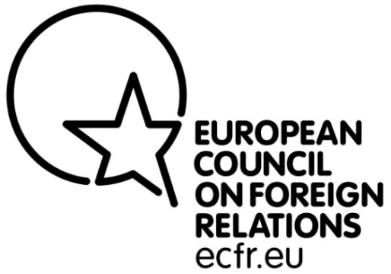

Post: Project Officer, Middle East Peace Process (MEPP) Project
Reporting to: MEPP Policy Fellows
Location: London
Deadline for Application: 27 March 2012 23:00 UK Time
Interviews To Be Held: 11 April 2012
Start Date: as soon as possible
Duration: 6 months, full time – possibly extensible

Only candidates available on the date of interviews and who can start quickly should apply

Background to appointment
The European Council on Foreign Relations (ECFR) is a pan-European initiative which seeks to conduct research and promote informed debate across Europe on the development of coherent, effective and values-based European foreign policy.
- A pan-European Council. ECFR has brought together a distinguished Council of over one hundred Members - politicians, decision makers, thinkers and business people from the EU's member states and candidate countries.
- A physical presence in the main EU member states. ECFR, uniquely among European think-tanks, has offices in Berlin, London, Madrid, Paris, Rome, Sofia and Warsaw. Our offices are platforms for research, debate, advocacy and communications.
- A distinctive research and policy development process. ECFR has brought together a team of distinguished researchers and practitioners from all over Europe to advance its objectives through innovative projects with a pan-European focus. ECFR's activities include primary research, publication of policy reports, private meetings and public debates, ‘friends of ECFR' gatherings in EU capitals and outreach to strategic media outlets.

ECFR’s Middle East and North Africa (MENA) Programme was launched in 2011, and has rapidly acquired authority and influence. Initially focussing on the events of the Arab Spring, it is now embarking on a major programme of work relating to the Israel/Palestine conflict – the MEPP Project.
For more information: www.ecfr.eu

Responsibilities
- Act as the London-based ‘anchor’ of the MEPP project: ensuring coordination between management and the policy fellows; monitoring the different workstrands and deadlines, and progress-chasing; liaising with donors/sponsors.
- Help process and analyse research data.
- Help identify and liaise with relevant policy, advocacy and think-tank contacts and contribute to the development of the project’s contact database.
- Support the project’s advocacy and outreach activities in different European countries (organization of events, distribution of publications, coordination of agendas and travel schedules).
- Help develop the project’s media outreach towards journalists, and keep track of its media work. Look after the relevant parts of the website, and make proposals for innovation.
- Help ensure that ECFR’s national offices are effectively included in the MEPP project.
- Provide administrative support to Senior Policy Fellows, such as coordinating travel and meetings.
- Other general responsibilities as may be reasonably requested over time.
Experience
- University degree in international affairs, EU affairs, and/or Middle Eastern studies or equivalent.
- Demonstrated knowledge and interest in MENA-related issues desirable; proficiency in Arabic or Hebrew is a plus.
- Some office experience, preferably in a fast-paced environment requiring extensive interaction with others by phone and in writing.
- Excellent written and oral communication skills (a very high standard of written and spoken English).
- Highly IT (including website) proficient.
- Good knowledge of the EU (familiarity with international development issues is an asset).
Person specification
- Flexibility and ability to multi-task.
- Good organizational skills and eye for detail.
- Ability to work independently and as part of a multinational team and to develop effective relationships.
TERMS, CONDITIONS, SALARY
- Salary will be £26,000 pa, pro-rated.
- The benefits package includes medical & dental insurance, business travel insurance, and life and disability insurance. (Should the incumbent be extended in post beyond one year, he or she would then become eligible for a 10% private pension scheme.)
- 25 Days Annual Leave, pro-rated, plus all UK public holidays.
TO APPLY:
Please send a one page covering letter (with ref: ECFR MEPP Project Officer in the subject line) and your CV to: recruitment@ecfr.eu. Please restrict your CV to no more than two pages of A4. Please state your citizenship and status with respect to living and working in the UK.
PLEASE NOTE:
No phone calls please. Due to the large volume of candidates applying for positions within ECFR we will unfortunately be able to respond to your application only if you have been shortlisted for the role.
STRICTLY NO AGENCIES
ECFR is an equal opportunities employer.

