ecfr’s website analytics 2016
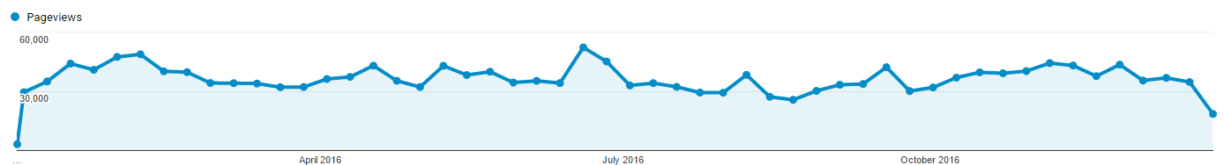
In 2016, ECFR’s website has recorded 1,646,650 unique pageviews by 691,037 users, which amounts to a 14,5% increase on unique pageviews and a 28% increase in the number of users compared to 2015.

Year | Users | Unique Pageviews
2010 | 125,977 | 498,513
2011 | 170,687 | 668,656
2012 | 224,564 | 812,324
2013 | 291,421 | 909,426
2014 | 387,805 | 1,077,409
2015 | 540,171 | 1,429,741
2016 | 691,037 | 1,646,650
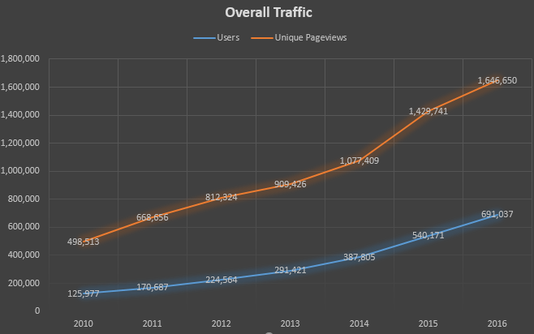
CONTENTS
55% of the unique pageviews was on a content page (article, special, publication, NO blogpost). 74% of the users of our website have been on a content page at least once.

top contents (seen by 4k+ users or 5k+ unique pageviews (metric expressed in unique pageviews)

1. | A quick guide to Libya's main players | Mattia Toaldo and Mary Fitzgerald | 17/5/16 | 21,611
2. | Putin’s hydra: Inside Russia’s intelligence services | Mark Galeotti | 11/5/16 | 20,446
3. | Lessons from Russia’s intervention in Syria | Gustav Gressel | 5/2/16 | 16,456
4. | Mapping the Yemen conflict | Adam Baron | 2015 | 13,848
5. | Life in the Grey Zones | Fredrik Wesslau & Sophia Pugsley | 15/1/16 | 9,849
6. | Brits abroad: How Brexit could hurt expats | Susi Dennison & Dina Pardijs | 20/6/2016 | 9,654
7. | The good, the bad and the Gülenists | Asli Aydintasbas | 23/9/16 | 9,149
8. | The new power couple: Russia and Iran in the Middle East | Ellie Geranmayeh & Kadri Liik | 13/9/16 | 8,073
9. | Connectivity Wars | Mark Leonard | 20/1/16 | 7,887
10. | Putin’s downfall: The coming crisis of the Russian regime | Nikolay Petrov | 19/4/16 | 7,604
11. | Lessons from the Norway-EU relationship | Ulf Sverdrup | 21/6/2016 | 6,736
12. | Russia 2030: A story of great power dreams and small victorious wars | Fredrik Wesslau and Andrew Wilson | 23/5/16 | 6,603
13. | Russia’s hybrid interference in Germany’s refugee policy | Gustav Gressel | 4/2/16 | 5,522
14. | China’s complicated foreign policy | Shi Yinhong | 31/3/2015 | 5,482*
15. | Europe's vulnerability on Russian gas | Chi-Kong Chyong & Vessela Tcherneva | 17/3/2015 | 5,376**
16. | How to talk to Russia | Kadri Liik | 18/12/15 | 5,265
17. | The world according to Europe’s insurgent parties: Putin, migration and people power | Susi Dennison & Dina Pardijs | 27/6/16 | 5,084
18. | The Future of Schengen | Susi Dennison & Dina Pardijs | 14/4/16 | 5,044

*11,313 unique pageviews including 2015
**11,821 unique pageviews including 2015
The list of the top 100 entries can be found here: http://www.ecfr.eu/page/-/top100contents2016.pdf

Commentaries (Unique Pageviews)

1. | Lessons from Russia’s intervention in Syria | Gustav Gressel | 5/2/16 | 16,456
2. | Lessons from the Norway-EU relationship | Ulf Sverdrup | 21/6/2016 | 6,736
3. | Russia’s hybrid interference in Germany’s refugee policy | Gustav Gressel | 4/2/16 | 5,522
4. | China’s complicated foreign policy | Shi Yinhong | 31/3/2015 | 5,482
5. | Europe's vulnerability on Russian gas | Chi-Kong Chyong & Vessela Tcherneva | 17/3/2015 | 5,376
6. | How to talk to Russia | Kadri Liik | 18/12/15 | 5,265
7. | Taking Turkey seriously | Carl Bildt | 12/08/16 | 4,738
8. | The EU, Morocco, and the Western Sahara: a chance for justice | Vish Sakthivel | 10/6/16 | 4,641
9. | How Russia has come to loathe the West | Maria Lipman | 13/3/15 | 4,513*
10. | Ten global consequences of the Ukraine crisis | vv.aa. | 16/6/14 | 4,436**

*all-time 21,858
**all-time 13,898

publications (Unique Pageviews)

1. | Putin’s hydra: Inside Russia’s intelligence services | Mark Galeotti | 11/5/16 | 20,446
2. | Brits abroad: How Brexit could hurt expats | Susi Dennison & Dina Pardijs | 20/6/2016 | 9,654
3. | The good, the bad and the Gülenists | Asli Aydintasbas | 23/9/16 | 9,149
4. | The new power couple: Russia and Iran in the Middle East | Ellie Geranmayeh & Kadri Liik | 13/9/16 | 8,073
5. | Connectivity Wars | Mark Leonard | 20/1/16 | 7,887
6. | Putin’s downfall: The coming crisis of the Russian regime | Nikolay Petrov | 19/4/16 | 7,604
7. | Russia 2030: A story of great power dreams and small victorious wars | Fredrik Wesslau and Andrew Wilson | 23/5/16 | 6,603
8. | The world according to Europe’s insurgent parties: Putin, migration and people power | Susi Dennison & Dina Pardijs | 27/6/16 | 5,084
9. | Survival of the richest: How oligarchs block reform in Ukraine | Andrew Wilson | 14/4/16 | 4,614
10. | China and Russia: Gaming the West | Mathieu Duchâtel & François Godement | 2/11/16 | 4,508

publications (unique downloads)

1. | Putin’s hydra: Inside Russia’s intelligence services | Mark Galeotti | 11/5/16 | 3720
2. | Connectivity Wars | Mark Leonard | 20/1/16 | 2834
3. | Russia 2030: A story of great power dreams and small victorious wars | Fredrik Wesslau and Andrew Wilson | 23/5/16 | 1816
4. | Putin’s downfall: The coming crisis of the Russian regime | Nikolay Petrov | 19/4/16 | 7,604
5. | The new power couple: Russia and Iran in the Middle East | Ellie Geranmayeh & Kadri Liik | 13/9/16 | 1054

Publications Unique Pageviews and Unique Downloads (The ‘British Abroad’ publication has been excluded from the report*).
Month | Number of Publications | Unique Pageviews | Unique Downloads | % of downloads
Jan | 3 | 9883 | 4225 | 42.92
Feb | 2 | 7351 | 2923 | 39.84
Mar | 2 | 7225 | 2551 | 35.33
Apr | 5 | 15282 | 4167 | 27.24
May | 6 | 23463 | 6581 | 28.09
Jun | 6* | 18704 | 5124 | 28.40
Jul | 2 | 13664 | 3800 | 27.77
Aug | 1 | 6434 | 1944 | 30.21
Sep | 5 | 19895 | 3826 | 19.23
Oct | 5 | 19234 | 3742 | 19.45
Nov | 3 | 19136 | 3622 | 18.93
Dec | 3 | 18455 | 2949 | 15.98

% of VISITS TO PUBLICATIONS THAT ENDED WITH A PDF DOWNLOAD (+number of unique pageviews)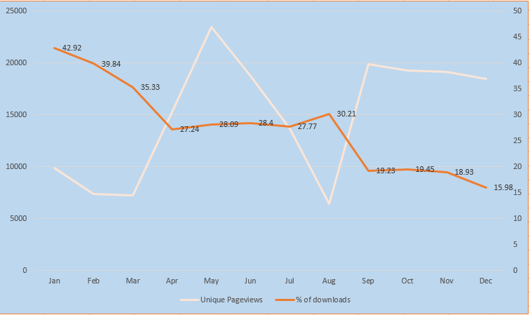
*Brexit: British Abroad.. has had a very unusual way of dissemination compared to other publications of our website, and therefore is not indicated to show the patterns of publications consumption. The publication was popular on Reddit but a tiny fractions of Reddit users downloaded the actual publication.

PODCASTS (PLAYS + downloads ON ALL PLATFORMS)

In 2016, ECFR Podcasts (Clips + World in 30 minutes, not including events recordings), have been listened 111,494 times and downloaded 4824 times.

1. | ECFR’s World in 30 Minutes: Who will be the next UN Secretary-General | Mark Leonard (host) | 2791
2. | ECFR’s World in 30 Minutes: German security | Mark Leonard (host) | 2439
3. | ECFR’s World in 30 Minutes: Donald Trump, NATO, and the new power couple Russia Iran | Mark Leonard (host) | 2385
4. | ECFR's World In 30 Minutes - How should Europe respond to President-elect Trump | Mark Leonard (host) | 2326
5. | ECFR’s World in 30 Minutes: Turkey’s failed coup | Mark Leonard (host) | 2190

acquisition (sources of traffic)

2016:
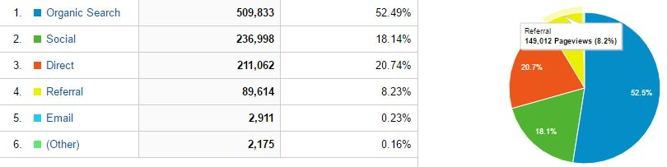
2015:
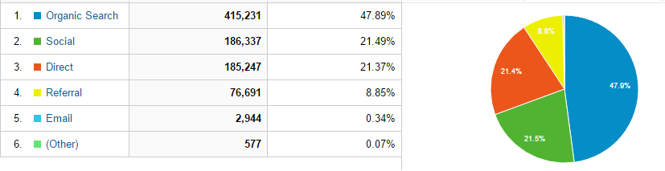
Traffic has been increasing from all sources in 2016 (minus emails – but we don’t have a reliable system set up to measure that, and much of email traffic is very likely been counted as direct traffic or referral).
Organic Search (through search engines – 97% of this traffic is represented by Google) has increased the most, which means our website has become better positioned over the last year. Search traffic amounts to more than 50% of overall traffic.
Social media traffic has also increased from 2015(+50 visits), thanks especially to our Twitter traffic (+47k visits from Twitter this year, from 118k to 168k). Facebook traffic has increased only slightly and it’s very likely the area when we can improve the most (+2k, from 51k to 53k). We’ve got 14k visits from Reddit (7k last year) and 3,5k from Linkedin (2k last year).

Geography

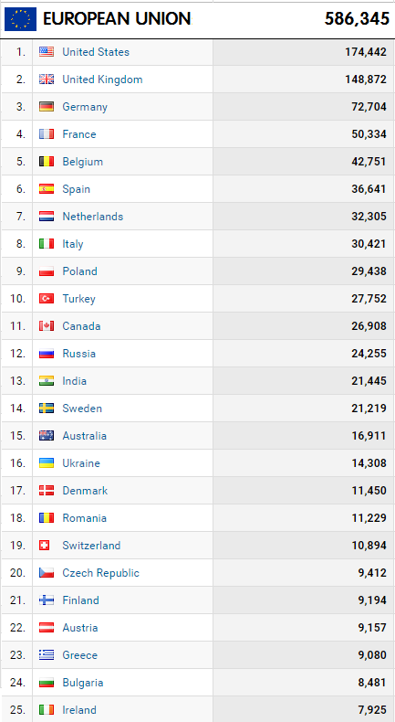

LM / 1-2017

